Woodworking through CNC operation

By Christian Espinoza

Since the dawn of mankind we have constructed many great works, from the stone hammer, to the wheel, to the current reality of precision design. Woodworking goes back as far as humanity picking up their first stone tools. However, the 21st century has been heavily influenced by the idea of CNC machining. Whether it is prototyping, mass production, custom designs, or one-off projects, CNC has become its own industry. This doesn’t make CNC any better or worse for woodworking than conventional methods, rather it is just a different way of woodworking that focuses more on digital rather than hands-on preparation, rendering the operation with precise measurements rather than eyeballing and hand carving.

The initialization “CNC” stands for Computer Numeric Controls, meaning that these machines are computer-programmed to move with absolute precision down to one thousandth of an inch (for reference, this is approximately the thickness of a human hair). Mainly used for cutting and carving, these machines use “cutting bits” or “tools” which come in an infinite selection of shapes and sizes, for virtually any material. The cutting is guided by a series of motors that move the bit along various axes. The amount of axes that the machines can travel on ranges from 3 to 7 axes.

We will begin with a simple 3-axis machine, shown below, which is the most common setup for CNC. The 3 axes are most commonly referred to as the “X” axis, the “Y” axis, and the “Z” axis.

3 Axis CNC

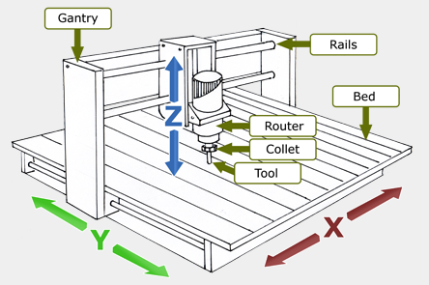

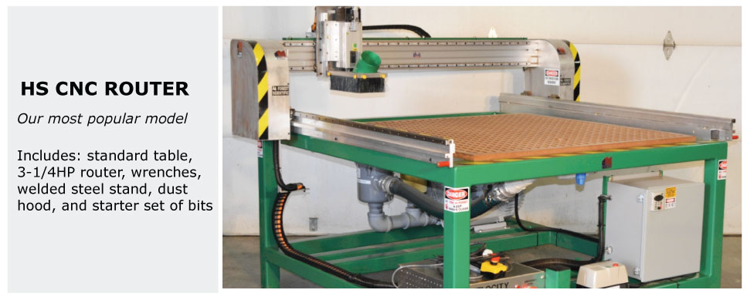 The CNC machine we use at the Sacramento City College Makerspace is a 3-axis machine with a 4 foot by 8 foot build space, big enough for an entire 4x8 sheet of plywood.

These machines, also commonly known as CNC “routers”, can achieve many cutting and carving operations. Bed sizes range from just a few square inches up to 200 square feet (or more!) depending on the model. Despite the hundreds of different models out there, they all perform similar operations when it comes to any given job. This means I can use many machines for the same operation, or more efficiently use one machine for many operations. In this manual, we will see how the actual cutting and carving operations occur, as well as examples of such operations. Below is an image of a CNC router in the middle of a “cutting” job, meaning the tool will cut all the way through the material of choice, in this case wood.

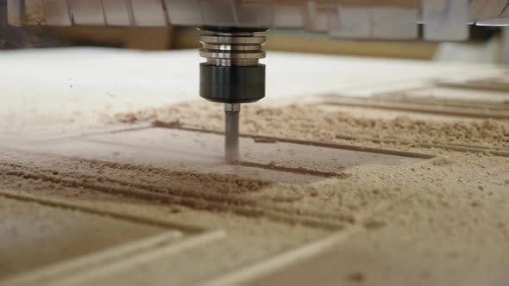

Here we see a similar router, only with a different bit known as a “ball nose”, performing

a carving or “pocket” operation on a pressed-maple skateboard.

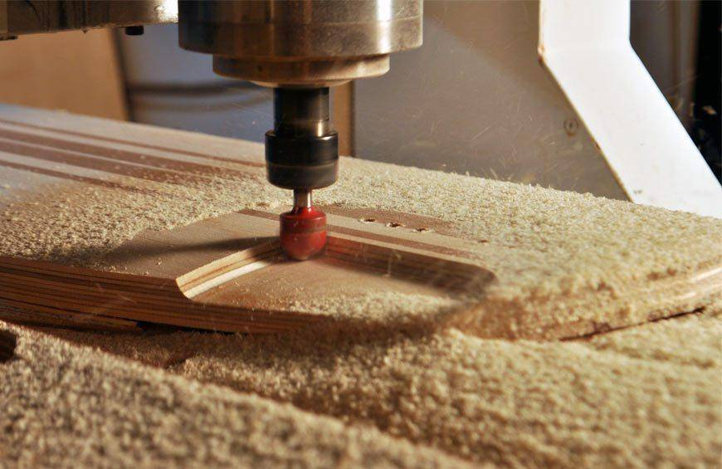

Next is an example image of a “V” bit, which is perfect for sign making and shapes with clean edges.

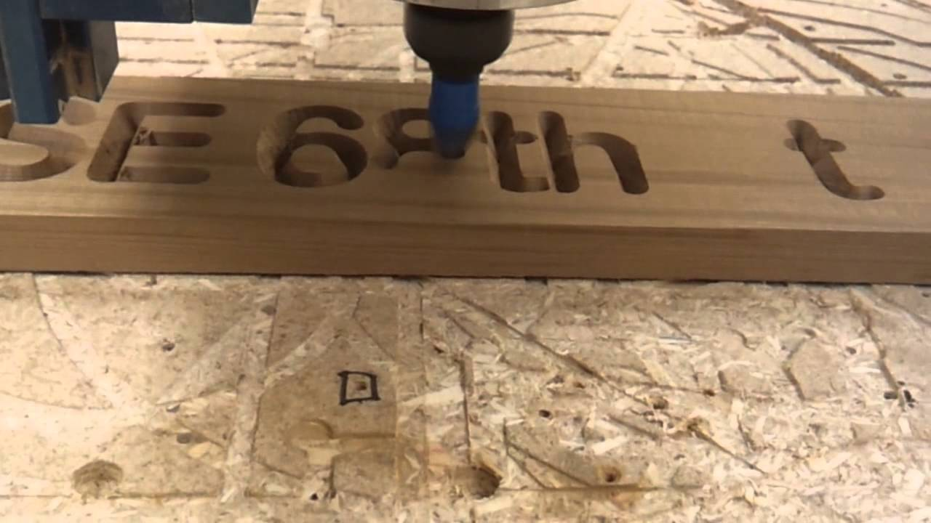

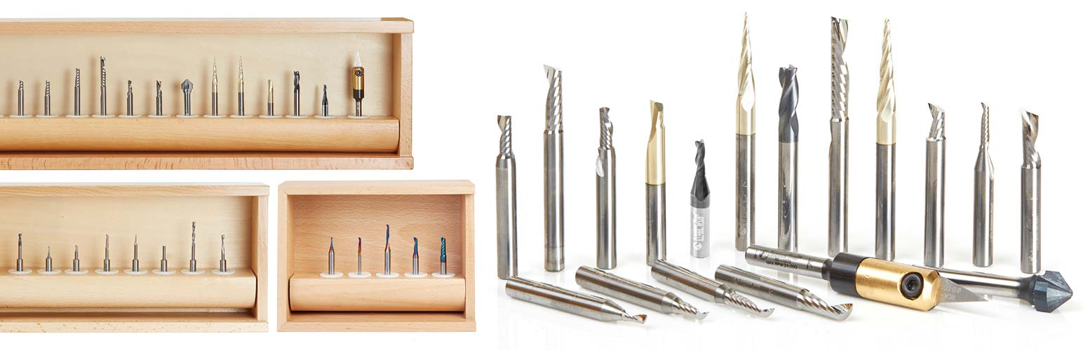Below we see a set of bits sold as a bundle, which includes one of each style of bit the company sells.

These are just a few examples of what bits are out there. With the massive inventory that exist commercially, machinists and engineers can create just about anything imaginable.

The only limits these routers can run into are with the bits are on hand. Take for example an operation in which a half inch hole must be cut. A full one-inch cutter won’t be able to make the cut, as the bit must be exactly the diameter of the hole or less. This means that every bit used in a router must match the required operation so that the designs come out with absolute precision. As such, many operations require a specific bit that can perform a specific function.

Whether it’s cutting, carving, or sign-making, any and every operation that involves a CNC machine will have to be created and simulated in some form of software. For this example I’m going to be focusing on Fusion 360 a software by Autodesk, the same company that created AutoCad. The interface of Fusion 360 and its machining capability is smooth and easy to use, especially for those unexperienced with CNC, so let us begin the digital process in Fusion 360.



Below is an image of the current Fusion 360 interface as of September 2019. This interface frequently updates, so the image may not exactly match future versions. Fusion is currently free to students, and a 3 year license is available via any Autodesk account established with a .edu email.

Let’s open up Fusion 360 below.

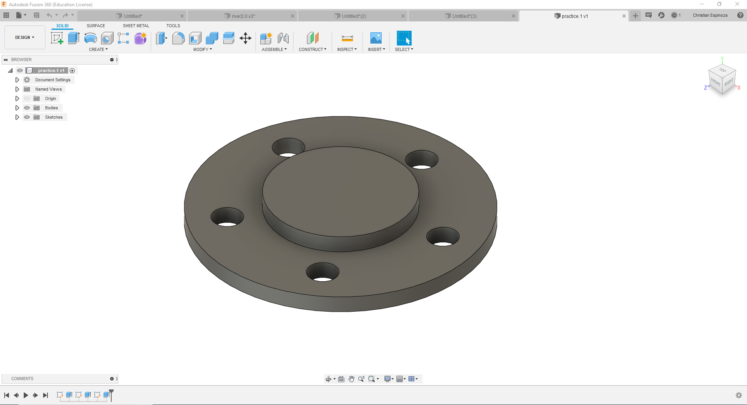

Here we see a spacer I designed in Fusion’s design environment. We will cut this spacer on our CNC router using wood, for prototyping purposes. We first need to move from our design space to our manufacturing space to begin the CAM (Computer Aided Manufacturing) process.

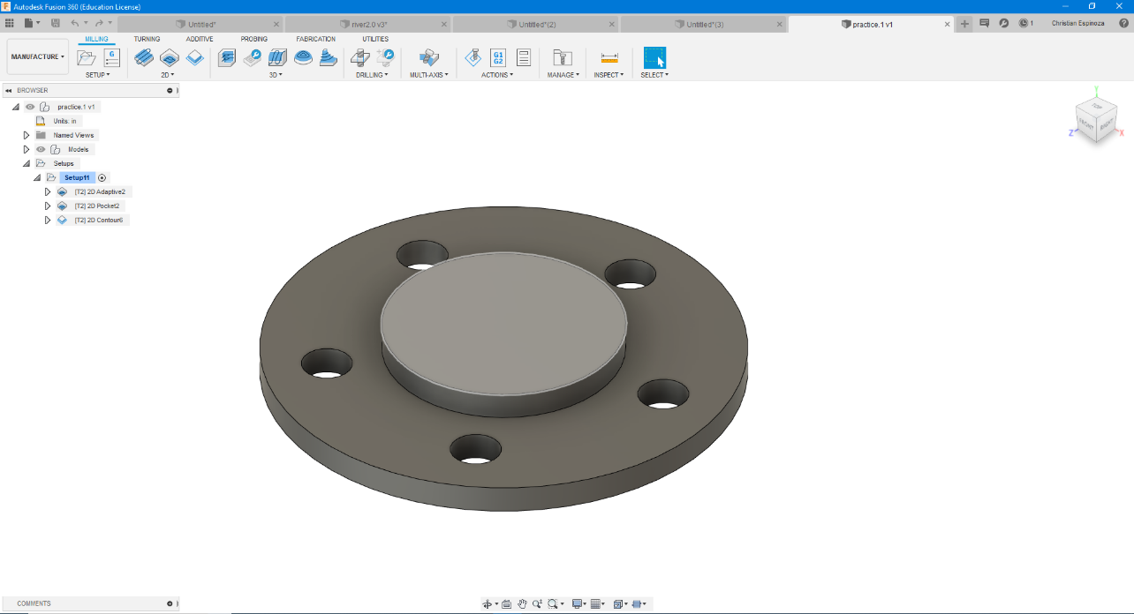Click Design on the top left, and select Manufacturing from the drop-down menu.

Every router has a set amount of power available (dictated by its primary cutting motor), which along with the bed size determine the physical limits of our project and the bits we will be using. Since this part is only 6 inches in diameter, it will absolutely fit within our 4 foot by 8 foot router bed, and our 6+ horsepower motor will definitely cut any wood we choose.

Let’s take a closer look at our part’s geometry so we can select the proper bit for our job. Since the smallest geometry is 0.63 inches we will need a bit with a smaller cutting diameter. Let’s choose a 0.5 inch bit so we have plenty of clearance.

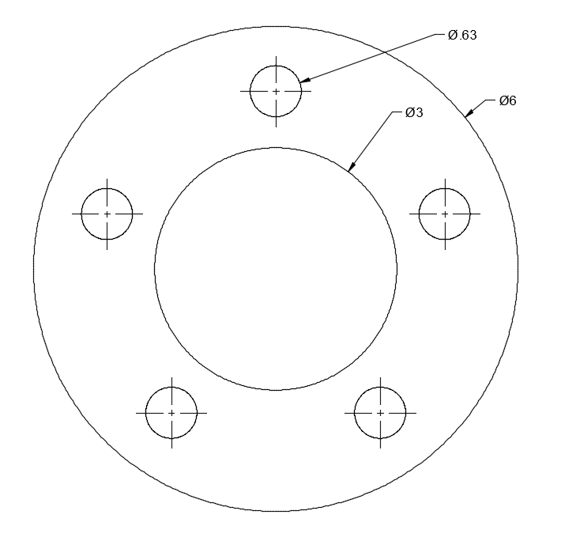

Before we can create any tool paths, we need to tool our bits. Tooling is a process in which we enter all of the physical dimensions of our tool into the program so we can use it in our cutting simulations.

First, open the “Manage” tab to see our tool library. In this library we will add/remove/modify our bits so they exactly match what we have available. We can see each bit and its exact dimensions in the image below.

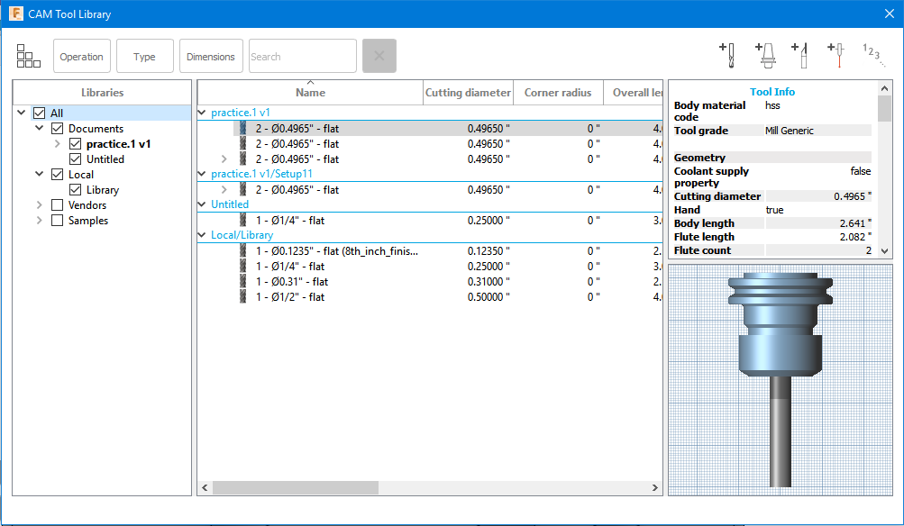

In the upper right hand corner we see the option that allows us to import new tools. This will take us to where we will add new tools.

New Milling Tool

Once the icon is selected, we will be able to add new tools into our tool library for whatever operation necessary.

Let’s take a closer look at the bits geometry and features, and add that 0.5 inch bit we will use to cut out our spacer. We will add every bit of information about the tool, from the number of cutting edges or “flutes”, to the physical construction of the bit, including all of its dimensions.

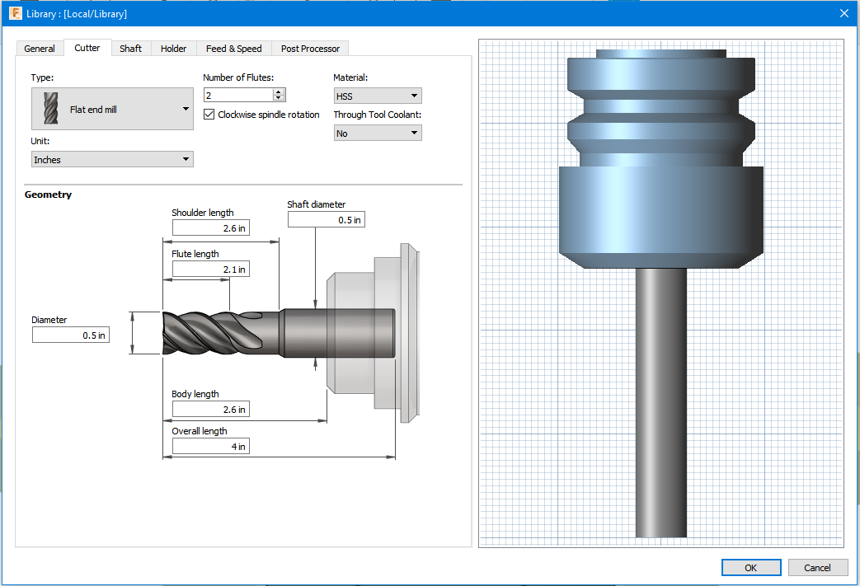

Now that we have digitally imported the tool, it is time to input our stock (the wood we will cut the part out of). Let’s use a small 12 inch by 12 inch piece of pine plywood that is about 0.75 inches in thickness.

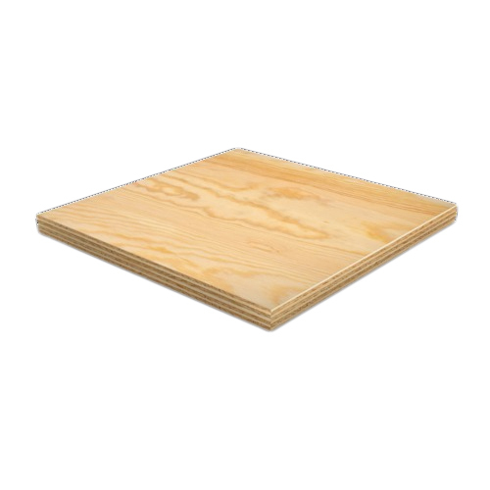

To begin modeling our stock, click the “set-up” tab in the upper left hand corner with the button-icon as shown below. In the second image we can see where our operations will be stored under our setups, as well as each of the tool paths we will generate.

 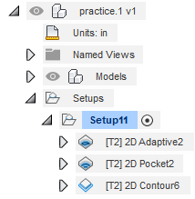

In the set up menu, we will now import our physical piece of wood into our digital space so Fusion 360 can use this information for our cut. Here we see the required to set up our part in the first two of three tabs of our set-up widow, ignoring the third tab for now.

First we orient our part so that the “Z” axis faces up, the “Y” axis faces the 8 foot length, and the X-axis faces the 4 foot length on our router. Choose the “Select Z axis/plane…” option from the Orientation menu, and click on any part of the model facing directly up. Since our part is round the X and Y-axis positioning can face any horizontal direction, so select any vertically-oriented plane for our X-axis.

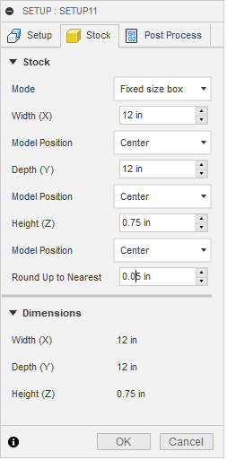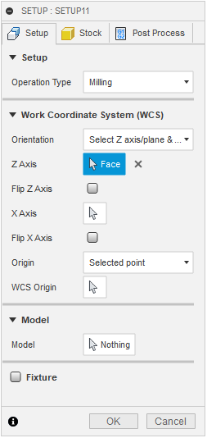Finally, in the Stock tab, we will input our stock dimensions so we can see what our part looks like within the piece we will cut it out of.

The spacer is centered inside of the stock.

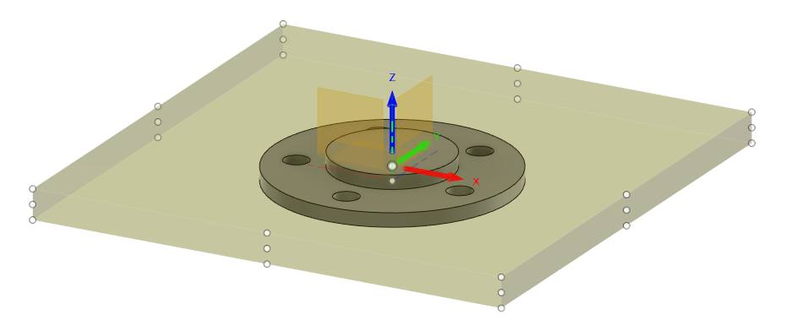

Now that our stock has been imported digitally, we can begin generating our cutting process. Let’s use the 0.5 inch bit that we added earlier to our operation. We will now generate a “toolpath”, which tells the machine where and how to move the bit.

Our first step is to pick the operation appropriate for the first toolpath. We want to first cut the holes and center cylinder, so the part is still bound to the stock which will prevent the part from moving during this process. Our first operation will be a “2D Adaptive Clearing” a good choice for milling out cavities (also known as “pockets”). We can see the icon in the 2D options. This operation will material in a spiral fashion, allowing for flat, even surfaces.

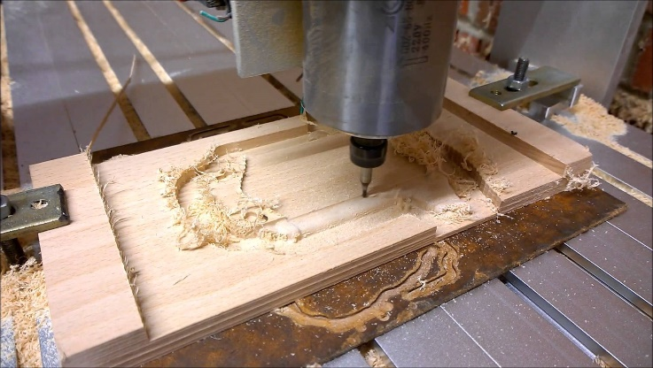A good example of a clearing or “pocket” cut in progress.

Once we have clicked on the icon, a window will open where we will move through a series of tabs to help us select the proper tool, geometry to cut, set height limits, determine what passes to use, and manage how our tool enters and leaves our stock (also known as “linking”). If you aren’t sure what to enter in one of the fields, most can be left at their defaults.

In the first tab, select the tool we created earlier. In the second tab, click on the box to the right of “Pocket Selections” and select the 5 holes in the part. The remaining tabs can be left alone for now, but feel free to click through them to familiarize yourself with what each contains.

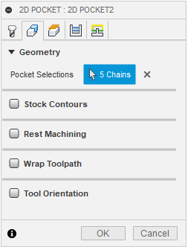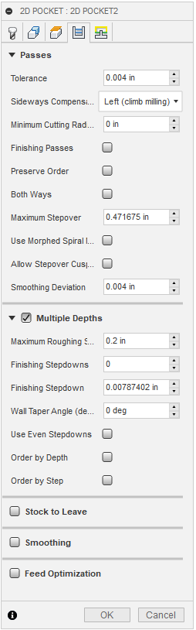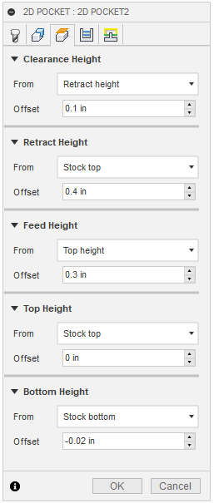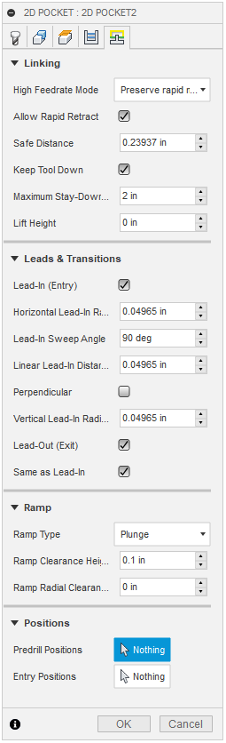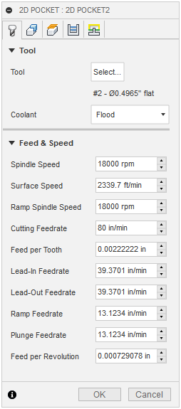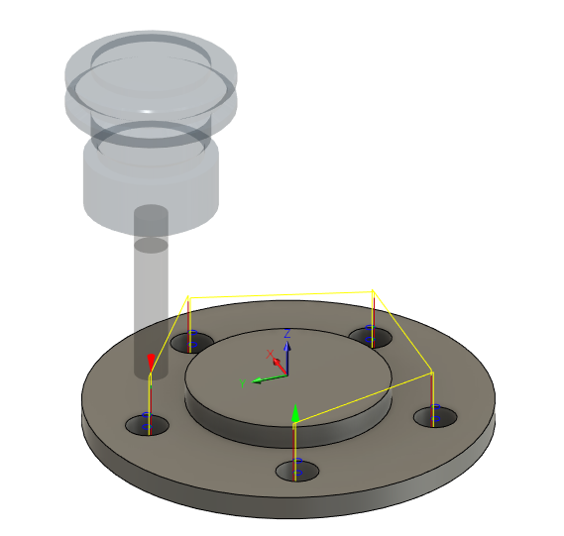We see an overview of this path in the image below, as well as each of the tabs.

Once this information has been entered, we can see what both our toolpath and stock will look like once are done with our first operation using the Simulation tool.

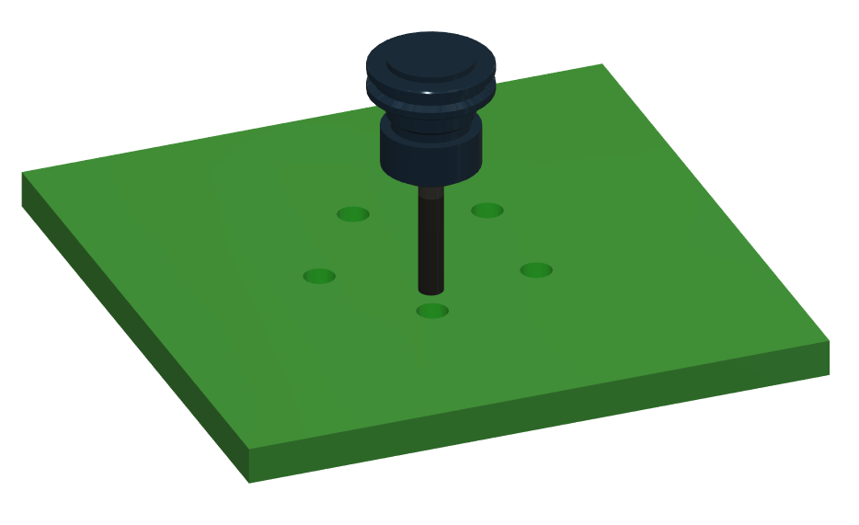

Let’s copy and paste this operation, since it can also be used for our next toolpath. We will now cut away the lower surface of the material as our second operation. We can see both our second path and second simulation in the image below.

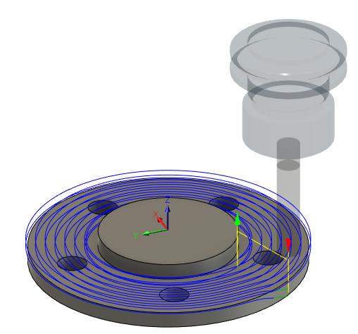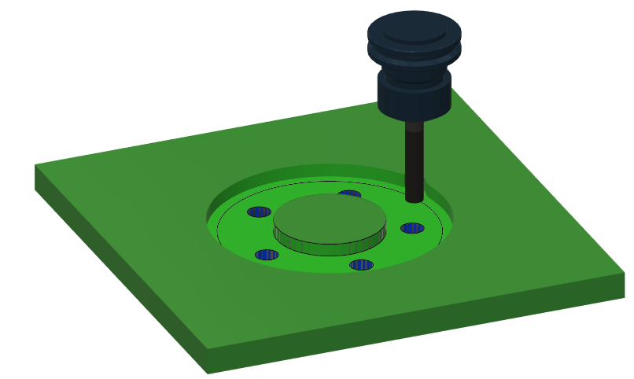

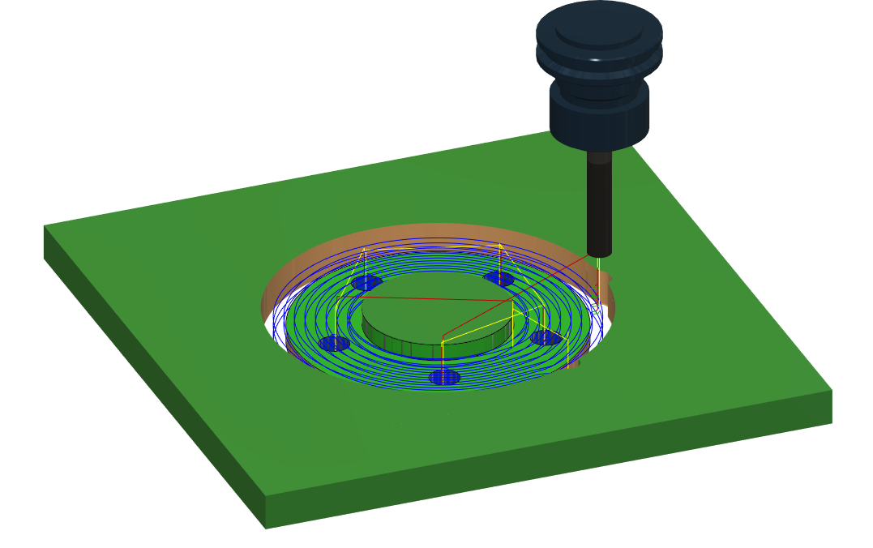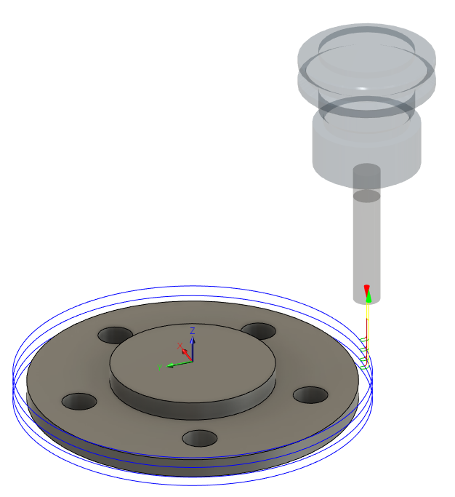Now for the final operation, we want to cut the piece out of the stock. We will do this with the Contour operation, in which we will select the edge of our stock. This will be the travel path at the edge of our part, and will fully separate it from our stock. We will use the same feeds and speeds as our last two operations

Our last step will be to “post-process” our CNC job, meaning that we will take all of the digital information we have just prepared, with all of our stock dimensions and tool paths, and convert everything into “G-code” that our CNC router can read.

*DON’T FREAK OUT*. This step happens at the click of a button and involves no manual programing. Click on the Post Process button in the Actions section, and adjust any necessary settings. Each machine will have a different Post Processor (found in the dropdown menu above “Output Folder”), and may require small changes depending on the specifics of your setup.

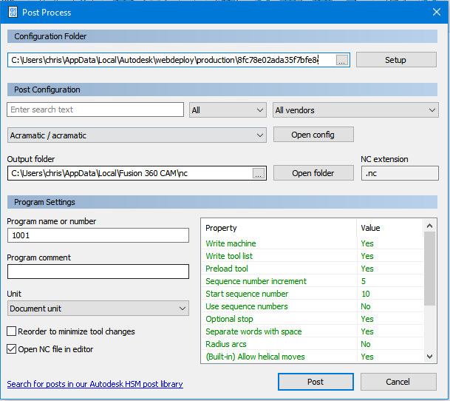

We are now ready for our cut to be performed by our CNC router.